Contents

Introduction 1

Prerequisites 1

Capture a Windows Virtual Machine 1

Prepare the VM 1

Shutdown the VM 2

Capture Image 3

Listing the New Image 3

Delete Image 3

# Introduction

The purpose of this document is to show the attendee how to capture a Linux virtual machine to be used as image when creating new machines. This can be useful when the machine has a setup that needs to be distributed over several machines (e.g. cloud computing).

## Prerequisites

The attendee needs a working Linux virtual machine. Create one for example with the command:

azure vm create <vm-name> <image-name> <username> --location <location> --rdp

As image, you can use the Windows Server 2012 Datacenter image with the image name

a699494373c04fc0bc8f2bb1389d6106__Windows-Server-2012-Datacenter-201307.01-en.us-127GB.vhd

# Capture a Windows Virtual Machine

## Prepare the VM

Connect to the VM using an RDP client (“Remote Desktop” in Windows):

On the remote desktop, press Win+R and enter „cmd“ to execute a shell.

In the command prompt, enter the following command:

cd %windir%\system32\sysprep

sysprep.exe

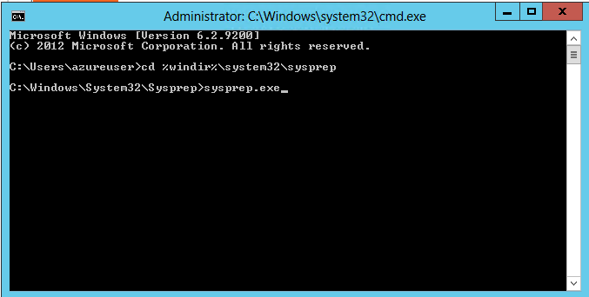

This will open a dialog box.

In the dialog box, select the following options:

* Select “Enter System Out-of-Box Experience (OOBE)”
* Check “Generalize”
* Select Shutdown

After selecting those options, click “Ok”:

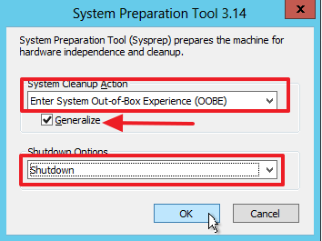

This will prepare your VM for capturing and then shut it down. The operation can take a couple of minutes.

## Shutdown the VM

You might have to manually shut down the VM. On your console, execute the command

azure vm shutdown <vm-name>

## Capture Image

The final step is to capture the VM image. In your console, use the command:

azure vm capture --delete <vm-name> <target-image-name>

This operation will capture the VM, store the image to <target-image-name> and (if successful) delete the VM. The delete operation is required.

The output of this operation should look similar to this:

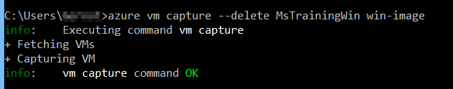

## Listing the New Image

Once the image is captured, you can use it to create new virtual machines. Check that your image is in the image gallery by executing the following command:

azure vm image list

You should find your image along the other available images:



## Delete Image

You can delete an image not needed by executing the following command:

azure vm image delete msrubuntu-image

The output of this operation should look similar to this:

